**SEQUENTIAL DIAGRAM**

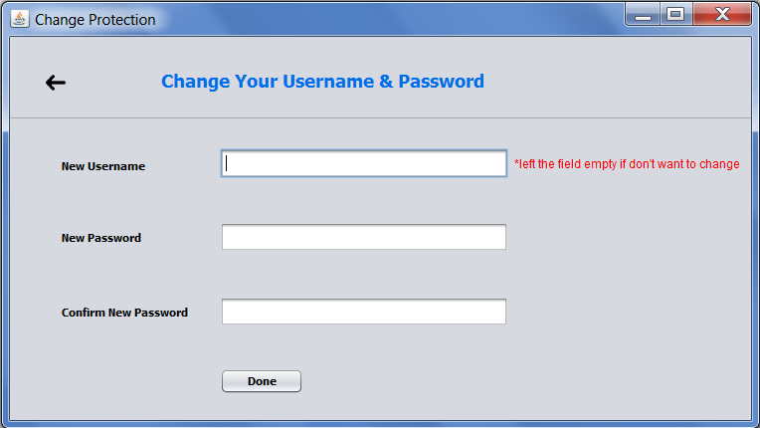

Change Password Window

In above Interface, three fields are there: *Username, Password* and *Confirm Password*.

User will input new username (if needed otherwise field can be left empty), new password and retype his new password in *New Password* field. If password entered matches with retyped password for confirmation and **DONE** button is pressed, username (if mentioned) and password will be changed:

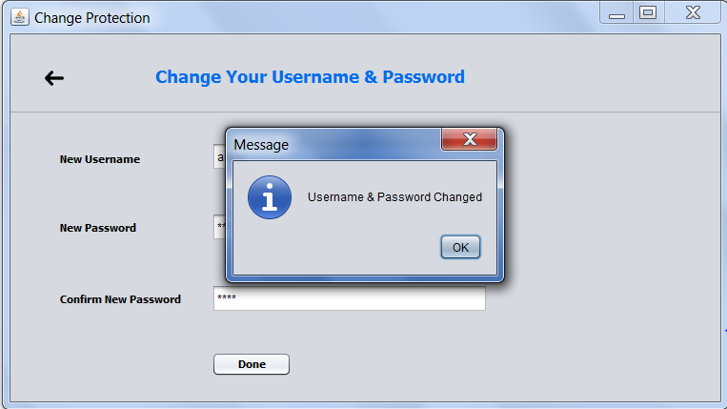

And if *Confirm Password* doesn’t match with P*assword* field, error appears:

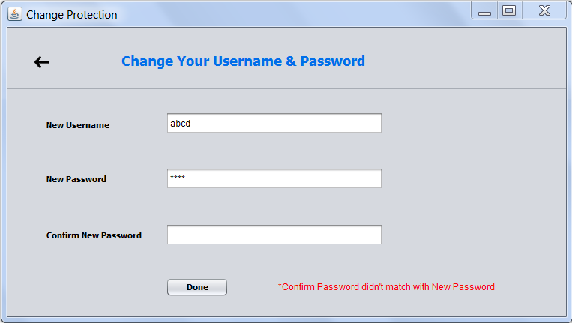

Error